**CODE:-**

#include <iostream>

using namespace std;

int main()

{

string s = "object", s2 = "", s3 = "";

for (int i = 0; i < 6; i++)

{

s2 = "";

s3 = "";

for (int j = 0; j < 6 - i; j++)

s2 += s[j];

cout << s2;

for (int j = 5 - i; j >= 0; j--)

{

cout.width(6 + i);

cout.setf(ios::right, ios::adjustfield);

s3 += s[j];

}

if (i == 5)

cout.fill('*');

cout << s3;

cout << endl;

}

for (int i = 4; i >= 0; i--)

{

s2 = "";

s3 = "";

for (int j = 0; j < 6 - i; j++)

s2 += s[j];

cout << s2;

cout.fill(' ');

for (int j = 5 - i; j >= 0; j--)

{

cout.width(6 + i);

cout.setf(ios::right, ios::adjustfield);

s3 += s[j];

}

cout << s3;

cout << endl;

}

}

**OUTPUT:-**

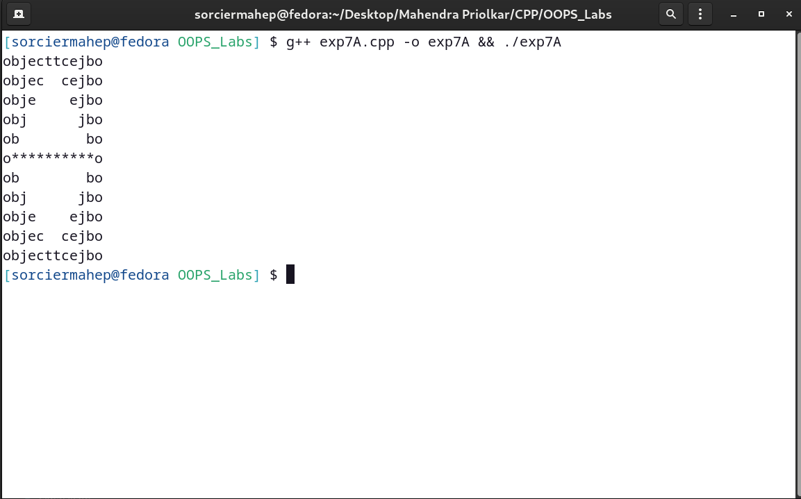

**CODE:-**

#include <iostream>

#include <string>

#include <iomanip>

using namespace std;

int main()

{

string str;

int words = -2, chars = 0, lines = -2;

cout << "Enter a string.\n";

do

{

getline(cin, str);

for (int i = 0; i <= str.length(); i++)

{

if (str[i] == '.' || str[i] == '\0')

lines++;

if (str[i] == ' ' || str[i] == '\0' || str[i] == '.')

words++;

if (str[i] != ' ' && str[i] != '.' && str[i] != '\0')

chars++;

}

} while (str.length());

cout.setf(ios::left, ios::adjustfield);

cout << setw(20) << "Number of words" << setw(25) << "Number of characters" << setw(25) << "Number of lines" << endl;

cout.setf(ios::right, ios::adjustfield);

cout << setw(15) << words << setw(25) << chars << setw(20) << lines << endl;

return 0;

}

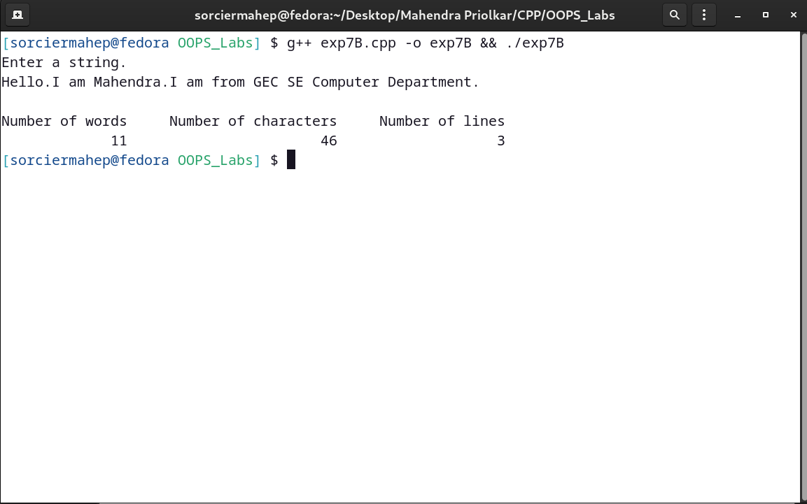**OUTPUT:-**

**CODE:-**

#include <iostream>

#include <iomanip>

using namespace std;

int main()

{

float sum;

cout << setw(2) << "n" << setw(20) << "Inverse_of_n" << setw(25) << "Sum_of_terms" << endl

<< endl;

for (int i = 1; i <= 10; i++)

{

cout << setw(2) << i << setw(18) << setprecision(4) << setiosflags(ios::showpoint) << setiosflags(ios::scientific) << 1.0 / i;

sum += 1.0 / i;

cout << setw(23) << resetiosflags(ios::scientific) << setprecision(5) << sum << endl;

}

}

**OUTPUT:-**

